**Class:** Final Year (Computer Science and Engineering)

**Year:** 2023-24 **Semester:** 1

**Course:** High Performance Computing Lab

**Practical No. 1**

**Exam Seat No: 2020BTECS00033**

**Name: Prathamesh Santosh Raje**

**Title of practical: Study of OpenMP**

**Q1. Differentiate between Software and Hardware Threads**

**Hardware Thread:** A "hardware thread" is a physical CPU or core. So, a 4 core CPU can genuinely support 4 hardware threads at once - the CPU really is doing 4 things at the same time. One hardware thread can run many software threads. In modern operating systems, this is often done by time slicing - each thread gets a few milliseconds to execute before the OS schedules another thread to run on that CPU. Since the OS switches back and forth between the threads quickly, it appears as if one CPU is doing more than one thing at once, but in reality, a core is still running only one hardware thread, which switches between many software threads.

**Software Thread:** Software threads are threads of execution managed by the operating system. Software threads are abstractions to the hardware to make multi-processing possible. If you have multiple software threads but there are not multiple resources then these software threads are a way to run all tasks in parallel by allocating resources for limited time (or using some other strategy) so that it appears that all threads are running in

parallel. These are managed by the operating system.

**Q2. Implement hello world program using openMP.**

**Code:**

#include <omp.h>

#include <stdio.h>

#include <pthread.h>

void main()

{

    printf("Hello World\n");

    int n=10;

    omp_set_num_threads(n);

    #pragma omp parallel

    {

        printf("Hello from thread number %d\n", omp_get_thread_num());

    }

}

**Output:**

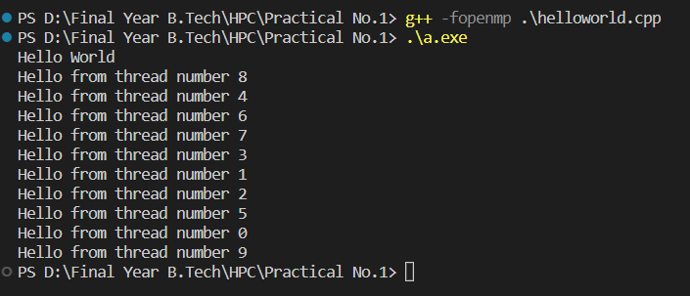

**Github Link:**